**Market Segmentation Analysis on**

**Electric Vehicle Market**

Report By -   
**PRASAD SONAR**

**Date: 1 April, 2024**

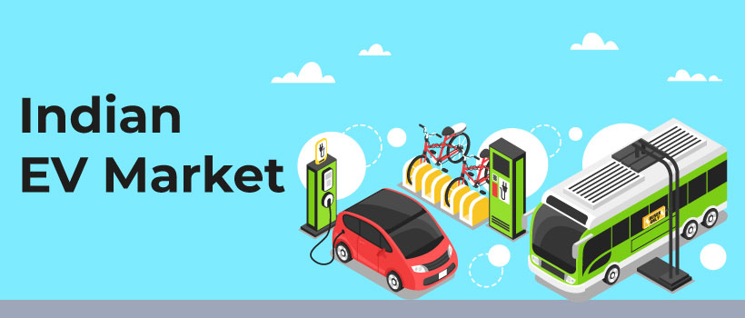

**Problem Statement:**

You are a team working under an Electric Vehicle Startup. The Startup is still deciding in which vehicle/customer space it will be develop its EVs.

You have to analyse the Electric Vehicle market in India using Segmentation analysis and come up with a feasible strategy to enter the market, targeting the segments most likely to use Electric vehicles.

**Fermi Estimation:**

This Fermi Estimation helps us estimate the potential size of the early market for our Electric Vehicle (EV) startup in India.

**1. Total Addressable Market (TAM):**

* **India's Population:** This is around 1.4 billion (Source: Worldometer).
* **Urban Population Focus:** We will target Tier 1 cities with better charging infrastructure. Assume 50% of the population lives in urban areas (Source: World Bank) - that is roughly 700 million.

**2. Segmenting the Market - Early Adopters:**

* **Early Adopter Rate:** Among the 700 million urban residents, 2.5% are likely early adopters for new technologies (Source: Marketing Metrics). This translates to 17.5 million early adopters.

**3. Penetration Rate:**

This is where we estimate the percentage of early adopters who might consider buying our EV. It depends on the chosen vehicle type (two-wheeler vs. four-wheeler). Let's consider both scenarios:

* **Two-Wheelers:** Two-wheelers dominate the market, so we might see a higher penetration rate. Assume a conservative 2% penetration rate among early adopters.
* **Four-Wheelers:** Due to potentially higher price points, assume a lower penetration rate of 1% for early adopters considering a four-wheeler EV.

**Potential Early Market Size:**

= Early Adopters * Penetration Rate

* Two-Wheeler Market: 17.5 million * 2% = 350,000
* Four-Wheeler Market: 17.5 million * 1% = 175,000

**Combined Early Market Potential:**

Approximately 525,000 (350,000 Two-wheeler + 175,000 Four-wheeler)

**Important Considerations:**

* This is a simplified estimation. Actual market size can vary depending on various factors (government incentives, charging infrastructure development, etc.).
* Further research is needed to refine our target segments and penetration rates.

**Conclusion:**

This Fermi Estimation suggests a potential early market size of around 525,000 for our EV startup in India. However, this is just a starting point. Further market segmentation analysis considering demographics, psychographics, and behavioural factors will help us identify the most promising target market and develop a successful entry strategy.

**Data Sources:**

**Data Sources:**

* **Government Sources:**
  + Mention the Ministry of New and Renewable Energy (MNRE) website as a potential source for reports or datasets on electric vehicle registrations or sales figures in India. You can link the MNRE website: <https://mnre.gov.in/>
* **Industry Associations:**
  + Highlight the Society of Indian Automobile Manufacturers (SIAM) as a source for sales data on different vehicle segments, including electric vehicles. Include a link to their website: <https://www.siam.in/>

**Datasets:**

Raw Datasets through <https://data.gov.in/> to Analyse EV Market in India:

[**https://data.gov.in/resource/category-wise-details-sold-electric-vehicles-manufactures-consumers-02-08-2023**](https://data.gov.in/resource/category-wise-details-sold-electric-vehicles-manufactures-consumers-02-08-2023)

[**https://data.gov.in/resource/stateut-wise-detailed-list-electric-vehicles-and-total-vehicles-roads-e-vahan-portal**](https://data.gov.in/resource/stateut-wise-detailed-list-electric-vehicles-and-total-vehicles-roads-e-vahan-portal)

[**https://data.gov.in/resource/stateut-wise-number-operational-public-electric-vehicles-ev-public-charging-station-pcs**](https://data.gov.in/resource/stateut-wise-number-operational-public-electric-vehicles-ev-public-charging-station-pcs)

For Consumers Cars Purchasing Behaviour:

<https://www.kaggle.com/datasets/karivedha/indian-consumers-cars-purchasing-behaviour>

**Data Pre-processing:**

1. **Data Cleaning and Encoding:**
   * Raw datasets underwent thorough cleaning to handle missing values, duplicates, and inconsistencies.
   * Categorical variables were encoded, depending on the nature of the data.
   * For example, categorical features such as profession, marital status, education, and loan status were encoded for further analysis.
2. **Scaling Numerical Features:**
   * Numerical features were standardized using the StandardScaler to ensure uniformity and comparability across different scales.
   * This step was crucial for clustering algorithms such as KMeans, which are sensitive to the scale of the features.
3. **Clustering Using KMeans:**
   * KMeans clustering algorithm was applied to segment the dataset into distinct clusters based on similarities in feature space.
   * The optimal number of clusters was determined using the elbow method, which indicated significant inertia reduction at four clusters.
4. **Dimensionality Reduction with PCA:**
   * Principal Component Analysis (PCA) was utilized to reduce the dimensionality of the data while preserving important information.
   * PCA helped visualize the data in a lower-dimensional space, making it easier to interpret and analyse.

**Code:**

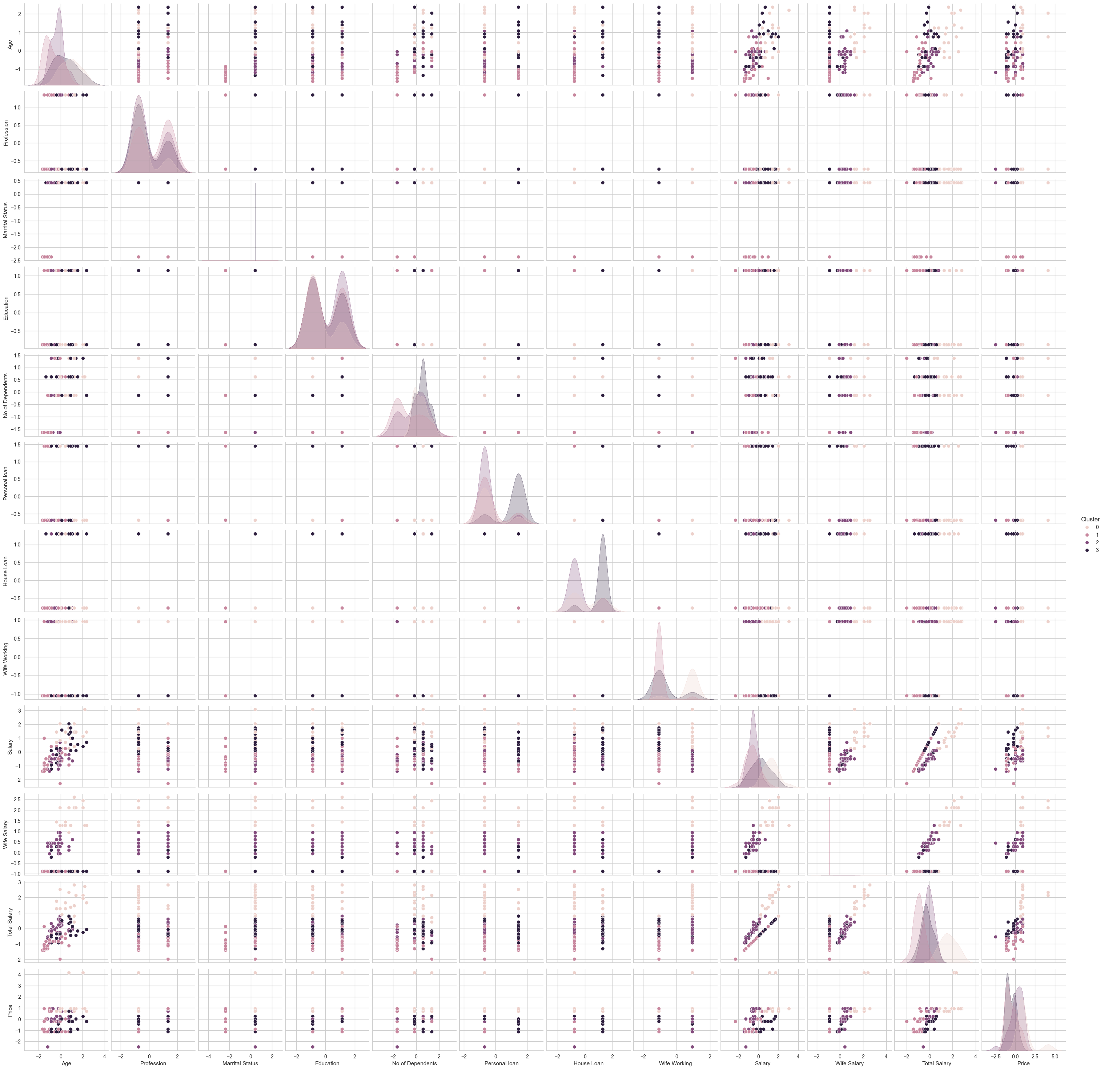

**Cluster Segmentation:**

Based on the K-Means clustering analysis, four distinct market segments have emerged:

* **Cluster 0: Urban EV Enthusiasts** (Consider revising if income isn't part of your data)
  + Characteristics: This cluster likely represents individuals residing in urban areas with a strong preference for electric vehicles. They might show interest in advanced features and environmental sustainability.
  + Marketing Strategy: Focus on highlighting the technological advancements and eco-friendly aspects of your EV models. Consider offering premium features and targeting environmentally conscious consumers.
* **Cluster 1: Urban Family-Oriented Buyers**
  + Characteristics: This cluster encompasses urban families who prioritize practicality and affordability in EVs. They might have a focus on family-friendly features and cost-effectiveness.
  + Marketing Strategy: Promote the practicality and affordability of your EV models. Emphasize features that cater to families and highlight cost savings associated with electric vehicles.
* **Cluster 2: Rural EV Potential**
  + Characteristics: This cluster likely represents consumers residing in rural areas. They might have specific needs and considerations regarding electric vehicle adoption.
  + Marketing Strategy: Develop EV solutions tailored to rural mobility needs. Consider focusing on cost-effective two-wheeler options and emphasizing the advantages of EVs for rural transportation.
* **Cluster 3: Young Urban Commuters**
  + Characteristics: This cluster likely comprises young, tech-savvy individuals in urban areas. They might prioritize convenience and environmental consciousness.
  + Marketing Strategy: Target compact and trendy EV models suitable for urban commuting. Offer innovative charging solutions and leverage digital marketing channels to reach this segment.

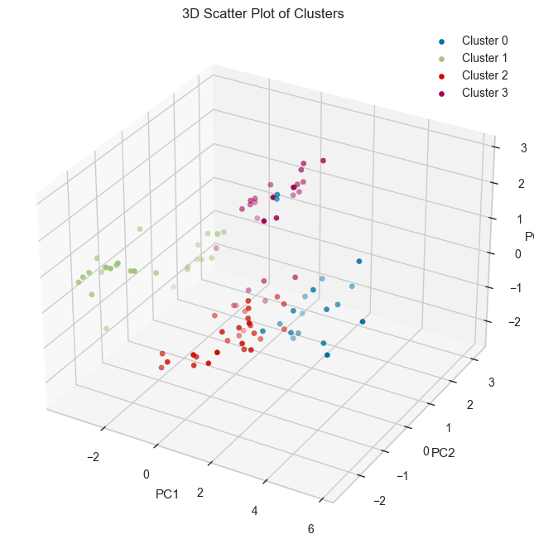

**Geographic Segmentation:**

This section explores the geographic distribution of electric vehicles (EVs) and charging infrastructure in India.

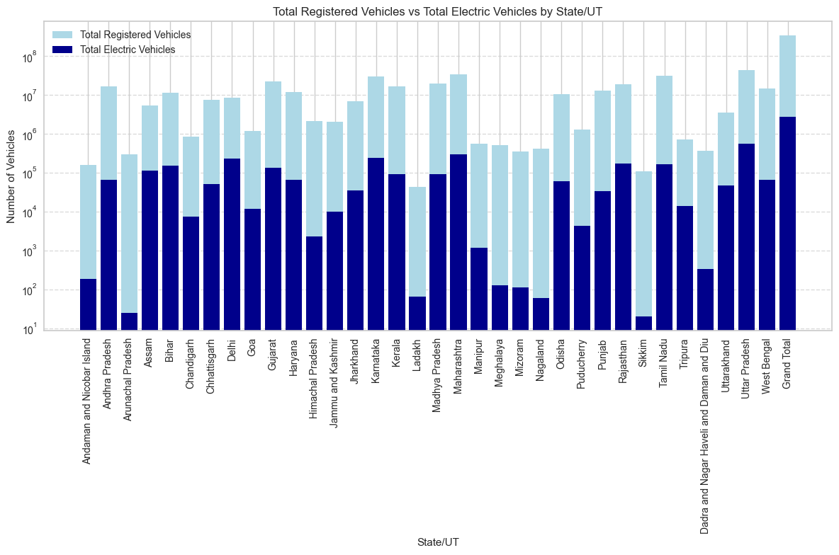

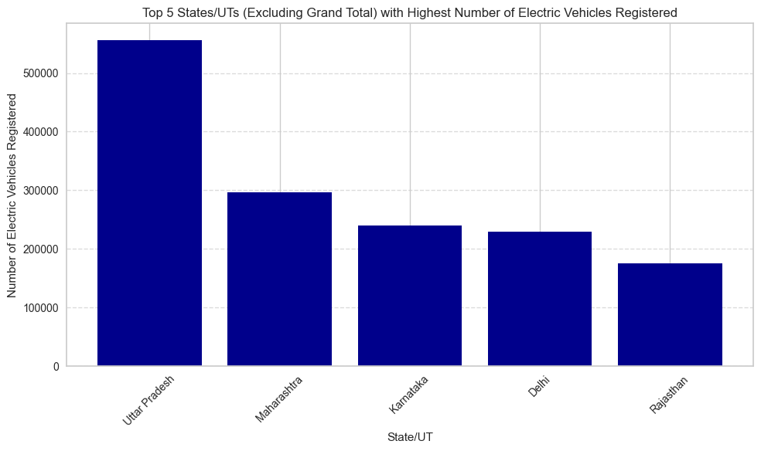

**Top Regions with Highest EV Adoption:**

* **Uttar Pradesh:** Leads the nation in the number of registered electric vehicles, signifying a significant level of EV adoption within the state.
* **Following States:** Maharashtra, Karnataka, Delhi, and Rajasthan also show promising signs of EV adoption with a substantial number of registered electric vehicles.

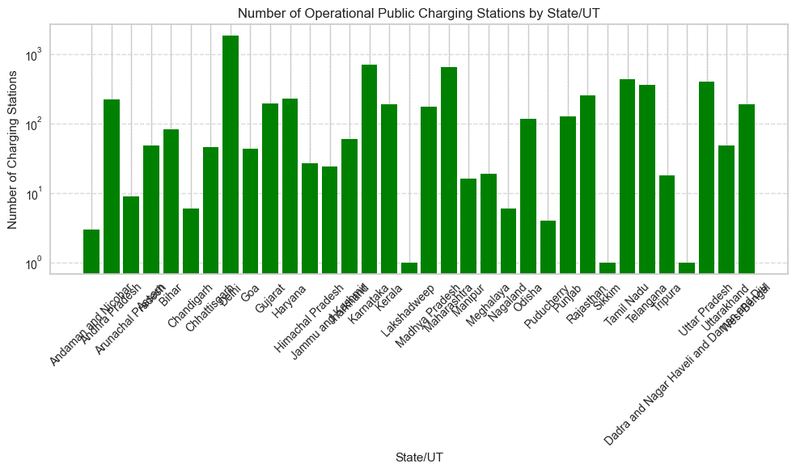

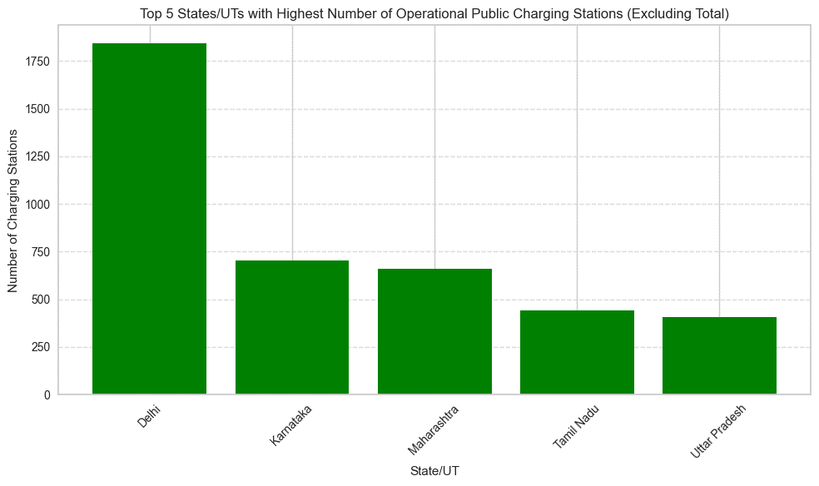

**Distribution of Charging Infrastructure:**

* **Delhi:** Takes the lead in providing operational public charging stations, indicating a strong commitment towards developing EV infrastructure within the state.
* **Other Major Players:** Karnataka, Maharashtra, Tamil Nadu, and Uttar Pradesh also demonstrate a notable presence of charging infrastructure, which likely contributes to the growth of the EV market in these regions.

**Insights:**

* The data suggests a regional disparity in EV adoption and charging infrastructure availability across India. While some states, like Uttar Pradesh and Delhi, are forging ahead, others may require additional efforts to promote EV usage.
* A well-developed network of charging stations is crucial for fostering EV adoption. States with a strong presence of charging infrastructure, like those listed above, are likely creating a more favourable environment for electric vehicles.

**Demographic Segmentation Analysis:**

Demographic segmentation groups customers based on traits such as age, gender, income, education, occupation, and family status, assuming that consumers with similar demographics will have similar needs and preferences. This segmentation approach enables organizations to develop targeted marketing strategies by focusing on the demographic groups most likely to purchase their products or services.

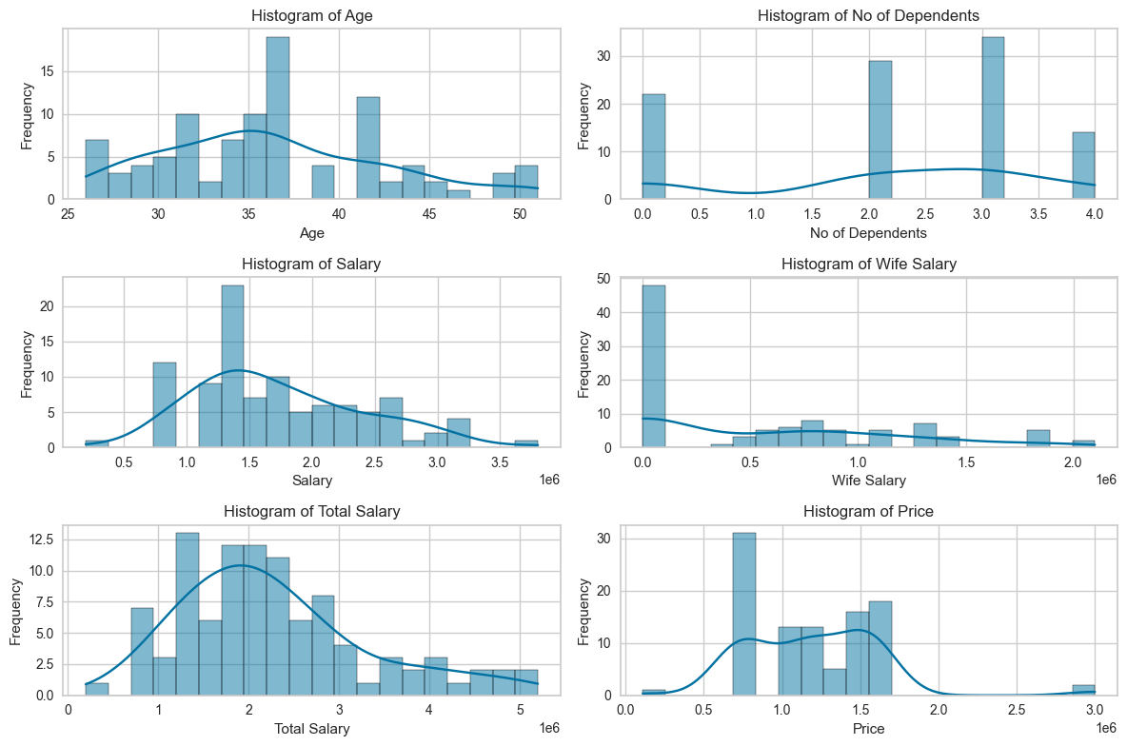

**Observations from Distribution Plot:**

1. **Age Group Distribution:** The majority of the consumer market falls within the age group of 25 to 50 years, indicating that individuals in this age range are key target demographics for electric vehicle adoption.
2. **Total Salary and Purchasing Behavior:** Consumers with an average total salary of around 30 lakh INR exhibit a higher propensity to purchase vehicles. This suggests that income level plays a significant role in influencing purchasing decisions in the EV market.

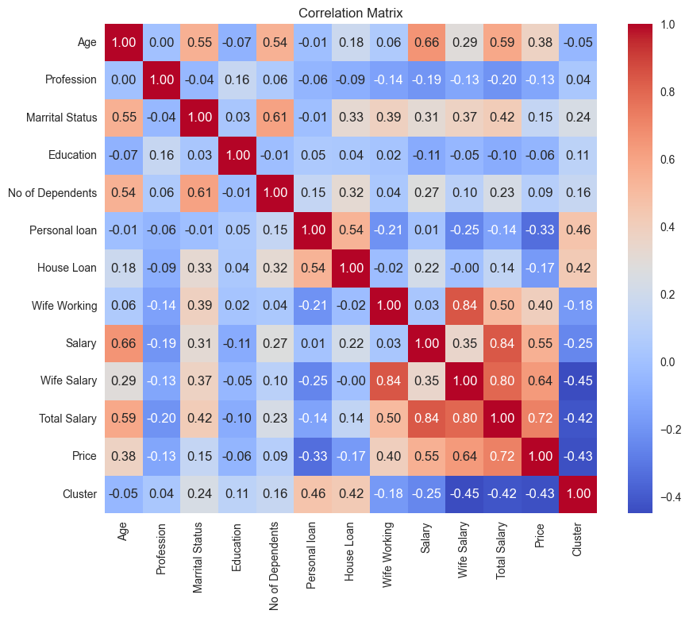

**Observations from Heatmap:**

1. **No Significant New Relationships:** While analyzing the heatmap, no striking new relationships were observed. However, the existing observations from the distribution plot were confirmed, reinforcing the importance of age and income in demographic segmentation.

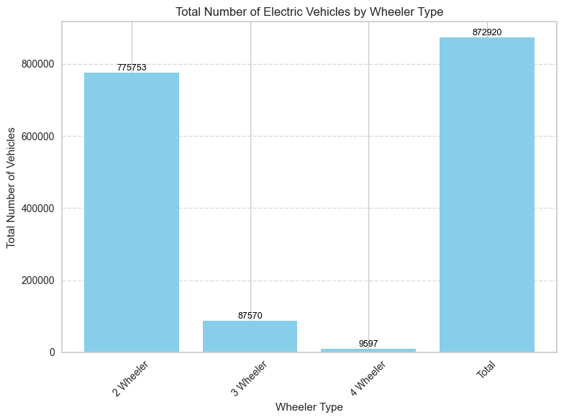

**Market Share Analysis:**

* The bar chart illustrates the domestic market share of automobiles in India.
* Two-wheelers dominate the Indian automobile market, capturing a significantly larger market share compared to other vehicle types.
* Given the substantial market share of two-wheelers, focusing on electric two-wheelers presents a lucrative opportunity for electric vehicle startups aiming to penetrate the Indian market.

**Demographic Segmentation Insights:**

1. **Age Group Targeting:** Targeting consumers within the age group of 25 to 50 years should be prioritized in marketing campaigns and product development efforts.
2. **Income-Based Marketing:** Tailoring marketing strategies to appeal to consumers with higher incomes, particularly those with an average total salary of around 30 lakh INR, can yield favourable results.
3. **Focus on Electric Two-Wheelers:** Considering the dominance of two-wheelers in the Indian automobile market, electric vehicle startups should emphasize the development and promotion of electric two-wheelers to capitalize on the market demand.

**Selection of Target Segment:**

After conducting comprehensive market segmentation analysis, the target segment for our electric vehicle startup is identified as environmentally conscious urban consumers aged between 25 to 50 years with above-average income levels (approximately 30 lakh INR). This demographic segment exhibits a strong inclination towards eco-friendly products and embraces innovative technology. They prioritize sustainability, prestige, and convenience in their purchasing decisions, making them ideal candidates for electric vehicle adoption.

**Customizing the Marketing Mix:**

To effectively target the identified segment, the marketing mix will be tailored to address their specific needs and preferences:

1. **Product:** Develop electric vehicle models with advanced features, sleek designs, and eco-friendly attributes. Emphasize the environmental benefits, technological innovation, and premium quality of the products.
2. **Price:** Implement competitive pricing strategies that offer value for money while reflecting the premium positioning of the electric vehicles. Offer flexible financing options and incentives to make EVs more affordable and attractive to the target segment.
3. **Promotion:** Launch targeted marketing campaigns across digital and traditional channels, highlighting the sustainability credentials, cutting-edge technology, and lifestyle benefits of electric vehicles. Collaborate with influencers, environmental organizations, and tech enthusiasts to amplify brand visibility and credibility.
4. **Place:** Establish a strong presence in urban areas with high population density and infrastructure support for electric vehicles. Partner with strategic retailers, charging station operators, and government agencies to ensure widespread availability and accessibility of EVs and charging infrastructure.

**Most Optimal Market Segments:**

The most optimal market segments to prioritize for market entry are:

1. Urban centers with high population density and supportive infrastructure for electric vehicles.
2. Regions with favorable government policies, incentives, and initiatives promoting EV adoption.
3. Demographic clusters characterized by a high concentration of environmentally conscious consumers with above-average income levels.

Based on the insights gleaned from our analysis of customer behaviour data, geographic distribution, and demographics, here's a breakdown of the most promising market segments for electric vehicles in India:

* 1. **Young Urban Enthusiasts:**
* **Potential Customers:** Tech-savvy young professionals (25-34 years old), likely with no dependents or a maximum of one dependent. These individuals reside in urban areas and exhibit a strong preference for new technologies and environmental sustainability.
* **Market Potential:** This segment represents early adopters who are willing to embrace innovation and potentially pay a premium for EVs with advanced features.
* **Marketing Strategy:** Focus on highlighting the cutting-edge technology, eco-friendly aspects, and stylish design of your EVs. Leverage digital marketing channels and target environmentally conscious young professionals in urban centers.
  1. **Family-Oriented Urban Buyers:**
* **Potential Customers:** Urban families with moderate income levels, likely having one or more children. This segment prioritizes practicality, affordability, and safety features in their vehicles.
* **Market Potential:** This is a sizeable segment with a growing demand for electric vehicles that cater to their family needs.
* **Marketing Strategy:** Emphasize the cost-effectiveness of EVs in terms of lower running costs and potential government subsidies. Promote features like spacious interiors, safety ratings, and child-friendly amenities. Craft marketing campaigns that resonate with the needs of urban families.
  1. **Early Adopters in Emerging EV Hubs:**
* **Potential Customers:** Young, tech-savvy individuals residing in states/UTs with a currently low number of EVs but a high EV penetration rate (e.g., some North-Eastern states). These individuals are likely aware of the benefits of EVs and might be early adopters in their regions.
* **Market Potential:** These regions represent significant growth potential for the EV market. By targeting early adopters, you can establish a strong brand presence and foster a culture of EV ownership.
* **Marketing Strategy:** Develop innovative marketing campaigns that create excitement around EVs and highlight the benefits of being an early adopter. Partner with local EV infrastructure providers to showcase the growing accessibility of charging.
  1. **Residents in Areas with Developed Charging Infrastructure (States like Delhi, Karnataka, etc.):**
* **Potential Customers:** This segment encompasses a broader demographic residing in states/UTs with a well-developed network of operational public charging stations. These individuals might be more open to considering EVs due to the reduced concerns about charging accessibility.
* **Market Potential:** States with strong charging infrastructure create a more favourable environment for EV adoption. By targeting these regions, you can tap into a wider customer base with a reduced barrier to entry (charging infrastructure).
* **Marketing Strategy:** Partner with local authorities or charging station providers to offer test drives or charging incentives. Promote the convenience and ease of owning an EV in these well-equipped regions.

**Link to GitHub profile with code:**